# GEE Downloader 2.0

## Operation process

1 First, you need to register a GEE account.

2 Open <https://code.earthengine.google.com/>

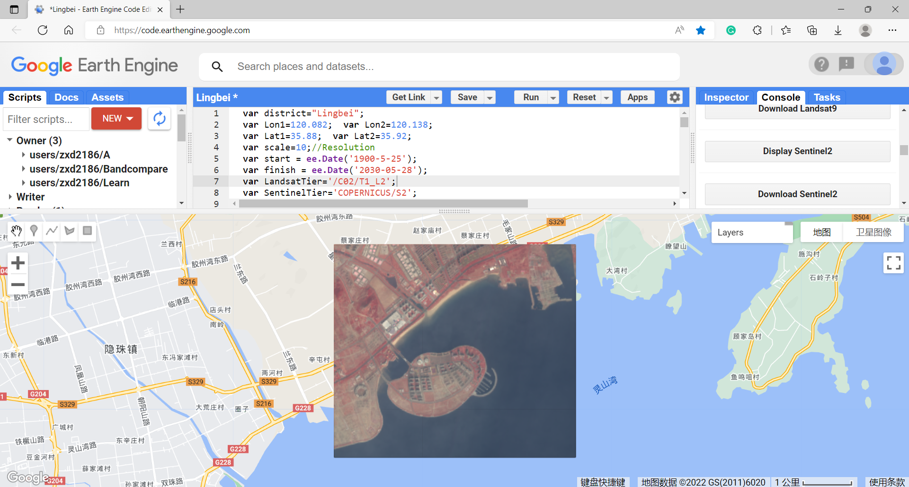

3 Copy the program in the next section to the top-middle Panel, and change the following sentences according to your district:

var district="Lingbei";

var Lon1=120.082; var Lon2=120.138;

var Lat1=35.88; var Lat2=35.92;

4 Click the run Button on the Panel.

5 Click the Display * Button and wait, you will see the mean image on the bottom Panel if every is OK; and then click the Download * Button and wait until all the tasks were fulfilled in the Tasks Panel.

6 Open the Tasks Panel, click the Run buttons.

7 Open your Google Drive(<https://drive.google.com/>), download the images.

## Program

var district="Lingbei";

var Lon1=120.082; var Lon2=120.138;

var Lat1=35.88; var Lat2=35.92;

var scale=10;//Resolution

var start = ee.Date('1900-5-25');

var finish = ee.Date('2030-05-28');

var LandsatTier='/C02/T1_L2';

var SentinelTier='COPERNICUS/S2';

var scalePseudo=scale/Math.cos((Lat1+Lat2)/2 * (Math.PI/180));

var geometry = ee.Geometry.Rectangle([Lon1, Lat1, Lon2, Lat2]);

Map.centerObject(geometry);

var CurBands=['NIR', 'Red', 'Green'];

var dataset;

var indexList;

function applyScaleFactors(image) {

var opticalBands = image.select('SR_B.').multiply(0.0000275).add(-0.2);

return image.addBands(opticalBands, null, true);

}

function Divide(image) {return image.divide(10000);}

var rgbVis = {min: 0,max: 0.4,bands: CurBands,};

function Create(Lc) {

print('LANDSAT/' +Lc + LandsatTier);

dataset = ee.ImageCollection('LANDSAT/' +Lc + LandsatTier)

.filterBounds(geometry)

.filterDate(start, finish)

.filter('CLOUD_COVER < 80')

;

dataset = dataset.map(applyScaleFactors);

print(dataset);

if (Lc=="LT04") {dataset=dataset.select(['SR_B4', 'SR_B3', 'SR_B2'], ['NIR', 'Red', 'Green']);}

if (Lc=="LT05") {dataset=dataset.select(['SR_B4', 'SR_B3', 'SR_B2'], ['NIR', 'Red', 'Green']);}

if (Lc=="LE07") {dataset=dataset.select(['SR_B4', 'SR_B3', 'SR_B2'], ['NIR', 'Red', 'Green']);}

if (Lc=="LC08") {dataset=dataset.select(['SR_B5', 'SR_B4', 'SR_B3'], ['NIR', 'Red', 'Green']);}

if (Lc=="LC09") {dataset=dataset.select(['SR_B5', 'SR_B4', 'SR_B3'], ['NIR', 'Red', 'Green']);}

indexList = dataset.reduceColumns(ee.Reducer.toList(), ["system:index"]).get("list");

print(indexList);

}

function CreateS(Lc) {

dataset = ee.ImageCollection(SentinelTier)

.filterBounds(geometry)

.filterDate(start, finish)

.filter('CLOUDY_PIXEL_PERCENTAGE < 80')

.map(Divide)

;

print("S2");

print(dataset);

dataset=dataset.select(['B8', 'B4', 'B3'], ['NIR', 'Red', 'Green']);

indexList = dataset.reduceColumns(ee.Reducer.toList(), ["system:index"]).get("list");

print(indexList);

}

function Display(Lc) {

if (1>0) {

var MeanImage = dataset.mean().select(CurBands);

MeanImage=MeanImage.clip(geometry);

Map.addLayer(MeanImage, rgbVis, Lc + '_Mean');

//exportImage(MeanImage, geometry, district+'_Mean' + start.get("year").getInfo() + '-' + finish.get("year").getInfo());

}

}

function Download() {

indexList.evaluate(function(indexs) {

for (var i=0; i<indexs.length; i++) {

//print(indexs[i]);

var Curimage = dataset.filter(ee.Filter.eq("system:index", indexs[i])).first();

var resampled = Curimage.resample('bicubic');

//Map.addLayer(resampled.clip(geometry), rgbVis, indexs[i]);

exportImage(resampled, geometry, indexs[i]);

}

});

}

function exportImage(Curimage, region, fileName) {

Export.image.toDrive({

image: Curimage,

description: fileName,

folder: district,

scale: scalePseudo,

region: geometry,

fileFormat: 'GeoTIFF',

formatOptions: {

cloudOptimized: true

},

crs: "EPSG:3857",//meter

maxPixels: 1e13

});

}

var L4_button = ui.Button({label: 'Display Landsat4',

onClick: function() {

Create("LT04");

Display("LT04");

}

});

print(L4_button);

var L4_Down = ui.Button({label: 'Download Landsat4',

onClick: function() {

Create("LT04");

Download();

}

});

print(L4_Down);

var L5_button = ui.Button({label: 'Display Landsat5',

onClick: function() {

Create("LT05");

Display("LT05");

}

});

print(L5_button);

var L5_Down = ui.Button({label: 'Download Landsat5',

onClick: function() {

Create("LT05");

Download();

}

});

print(L5_Down);

var L7_button = ui.Button({label: 'Display Landsat7',

onClick: function() {

Create("LE07");

Display("LE07");

}

});

print(L7_button);

var L7_Down = ui.Button({label: 'Download Landsat7',

onClick: function() {

Create("LE07");

Download();

}

});

print(L7_Down);

var L8_button = ui.Button({label: 'Display Landsat8',

onClick: function() {

Create("LC08");

Display("LC08");

}

});

print(L8_button);

var L8_Down = ui.Button({label: 'Download Landsat8',

onClick: function() {

Create("LC08");

Download();

}

});

print(L8_Down);

var L9_button = ui.Button({label: 'Display Landsat9',

onClick: function() {

Create("LC09");

Display("LC09");

}

});

print(L9_button);

var L9_Down = ui.Button({label: 'Download Landsat9',

onClick: function() {

Create("LC09");

Download();

}

});

print(L9_Down);

var S2_button = ui.Button({label: 'Display Sentinel2',

onClick: function() {

CreateS();

Display("S2");

}

});

print(S2_button);

var S2_Down = ui.Button({label: 'Download Sentinel2',

onClick: function() {

CreateS();

Download();

}

});

print(S2_Down);